PROJECT REPORT -2022
CINEMA TICKET BOOKING



GUIDED BY,  A.ASIA JOTHI, M.E., CONSOLIDATED LECTURER | DONE BY,  R KAMALESHVAR (194618)  K B BARATH (194610)  R KARTHICK (194621)  P KARTHIKEYAN (194623)

TAMILNADU GOVERNMENT POLYTECHNIC COLLEGE (AUTONOMOUS), MADURAI-11 DEPARTMENT OF COMPUTER ENGINEERING

In partial fulfillment of the requirements for the award of Diploma in Computer Engineering of the Directorate of Technical Education, Chennai-25

BONAFIDE CERTIFICATE

Certified that this project report “CINEMA TICKET BOOKING” is the bonafide work of ___________________________ who carried out the project work under my supervision.

SIGNATURE OF THE GUIDE SIGNATURE OF THE HEAD OF DEPT.,
A.ASIA JOTHI, M.E., Mrs.T.HEMA CHITRA, M.E.,
Consolidated Lecturer, Head of Department,
Department of Computer Engg, Department of Computer Engg,
Tamilnadu Govt Polytechnic college, Tamilnadu Govt Polytechnic college,
Madurai-11. Madurai-11.

Submitted for the board examinations held on ___________________.

IIN INTERNAL EXAMINER EXTERNAL EXAMINER

ABSTRACT

ABSTRACT
Cinema ticket booking website is aimed for Movie Viewers. Our Website helps the user to find the movie, theatres and availability of the movie tickets and automatically calculates the number of tickets and prices according to the classes. When a user decides to book a ticket, the booking information including name, address and billing information is stored in the database and the payment will be made through online. The Cinema ticket booking website is delivering the ticket virtually and the viewers can come to theatre peacefully without any rush in ticket counters. This website is very simple and everyone can easily understand which makes the user to book the ticket in more easy way.

CONTENTS

CONTENTS

CHAPTER TITLE PAGE NO
1. INTRODUCTION 01
2. | SYSTEM ANALYSIS  2.1 EXISTING SYSTEM  2.2 PROPOSED SYSTEM | 02  02  03
3. SYSTEM SPECIFICATION 04
3.1 HARDWARE REQUIREMENT 04
3.2 SOFTWARE REQUIREMENT 04
4. FLOW DIAGRAM 05
5. MODULE DESCRIPTION 07
6. SAMPLE CODING 08
7. SCREEN SHOTS 13
8. CONCLUSION 16
9. REFERENCES 17

CHAPTER-1
INTRODUCTION

1.INTRODUCTION
Cinema ticket booking system is a web portal where you can book tickets in advance , know your movie show timing, watch movie trailer and read reviews for the same.The objective of Cinema Reservation System is to provide the facility of booking movie tickets online. Customer can view timing of movie shows and book the show as per the availability. Cinema Reservation System is a PHP/MySQL based. This project provides ticket reservation system allowing bookings in a few easy steps. Users can easily book for Shows, Change time, Delete order and view all the shows available. Earlier,‌ ‌people‌ ‌had‌ ‌to‌ ‌stand‌ ‌in‌ ‌long‌ ‌queues‌ ‌to‌ ‌get‌ ‌tickets‌ ‌for‌ ‌events‌ ‌and‌ ‌movies.‌ ‌But‌ ‌with‌ ‌the‌ ‌advancement‌ ‌in‌ ‌technology,‌ ‌you‌ ‌can‌ ‌do‌ ‌the‌ ‌same‌ ‌from‌ ‌the‌ ‌comfort‌ ‌of‌ ‌your‌ ‌home.‌ ‌Just‌ ‌go‌ ‌to‌ ‌the‌ ‌website ‌and‌ ‌book‌ ‌tickets‌ ‌ ‌of‌ ‌your‌ ‌choice.‌

1

CHAPTER-2
SYSTEM ANALYSIS

2.SYSTEM ANALYSIS
2.1 EXISTING SYSTEM
The programming language is used to generate the HTML pages that the user sees. Instead of simply displaying the text, the programming languages can be used to generate the appropriate content based on the user, program inputs or parameters. For example, if a user logs into an administration panel of the system, the menu options, messages and features would be different for an administrator than for a user with fewer privileges. Thus the possibilities of how the content, navigation and features can be displayed on a website are endless and depend on the requirements of a particular business situation. In the end, the HTML page seen by the user looks the same as before, but the way it is constructed and generated is very different.
DISADVANTAGES
- The slow loading speed of a website.

- SEO features are limited and may require a further purchase and difficult for dynamic pages.

- Expensive design and plugins for the addition of certain special features to the website

2
2.2 PROPOSED SYSTEM
We propose a system which is more reliable, entertaining and easy than the present system. Our solution targets those users who do not have spare time to stand in queue for booking tickets. We propose an easy way of ordering and paying for the tickets without any delays and inconvenience. Book tickets to people who, without his physical presence is assured of a ticket before going to the theater. Customers who book tickets on their mobile phones, an instant messaging (m-ticket) will receive. By splashing the M- ticket at the counter of the multiplex, the client can receive physical tickets. No longer issue tickets to staff at the multiplex complex manual ticket availability and tracking system is needed. Ticket information can be accessed at any time for verification, which is safely stored in a database.
ADVANTAGES
- User-friendliness
- Quick deployment
- Easy for the non-technically minded.
- Easy to maintain and update
- User management and access permissions to other users

3

CHAPTER-3
SYSTEM SPECIFICATION

3.REQUIREMENTS
3.1HARDWARE REQUIREMENTS
- AMD Processor.
- 4GB RAM
- Keyboard
- Mouse
- 100GB Hard Disk Space
3.2 SOFTWARE REQUIREMENTS
- Xampp Server
- Windows 7/ 8/10
- Programming language: PHP,JAVASCRIPT
- Front End: HTML,CSS,BOOT STRAP
- Database: MySql.

4

CHAPTER-4
FLOW DIAGRAM

4.FLOW DIAGRAM

WEBSITE – DATA FLOW DIAGRAM

HOME PAGE

UPCOMING MOVIES
MOVIE TRAILERS
FLIMS IN THEATRES

VIEW UPCOMING MOVIES
VIEW MOVIE TRAILERS FROM YOUTUBE

BOOK OR VIEW MOVIES.

5
ADMIN – DATA FLOW DIAGRAM
ADMIN LOGIN

VALID USERNAME AND PASSWORD

YES NO
DASHBOARD

ALERT!
LOGIN FAILED.
EDIT, DELETE OR ADD MOVIES

HOME PAGE.

6

CHAPTER-5
MODULE DESCRIPTION

4.MODULE DESCRIPTION
Cinema ticket booking website contains three modules:
- HOME MODULE
- ADMIN MODULE
- MOVIE MODULE
HOME MODULE
The home module is the front page for our website which contains the following:-
- Upcoming Movies
- Trending Trailers
- Flims in Theatres
ADMIN MODULE
Admin page is the important page which is used to manage details about theaters and movies. There are some functionalities that are managed by Admin they are:
- Admin can add upcoming movies
- Admin can add new theatres
MOVIE MODULE
The Movies page is used to show the movies that are available to watch in theaters or the movies that are coming soon. The user can view the details of the movie such as cast, trailer and ratings of the movie.
7

CHAPTER-6
SAMPLE CODING

6. SAMPLE CODING
<div class="footer">
<div class="wrap">
<div class="footer-top">
<div class="col_1_of_4 span_1_of_4">
<div class="footer-nav">
<ul>
<li><a href="index.php" style="text-decoration:none;">Home</a></li>
<li><a href="movies_events.php" style="text-decoration:none;">Movies</a></li>
<li><a href="login.php" style="text-decoration:none;">Login</a></li>
</ul>
</div>
</div>
<div class="col_1_of_4 span_1_of_4">
<div class="textcontact">
<p>Theatre Assistance<br>
Online Movie Theatre Booking System<br>
Ph: 6969786969<br></p></div>
<div class="col_1_of_4 span_1_of_4">
<div class="call_info">
<p class="txt_3">Call us toll free:</p>
<p class="txt_4">1 200 696 39669</p>
</div>
<div class="col_1_of_4 span_1_of_4">
<div class=social>
<a href="#"><imgsrc="images/fb.png" alt=""/></a>
8
<a href="#"><imgsrc="images/tw.png" alt=""/></a>
<a href="#"><imgsrc="images/dribble.png" alt=""/></a>
<a href="#"><imgsrc="images/pinterest.png" alt=""/></a>
</div></div>
<div class="clear"></div>
</div>
</div>
</div>
</body>
</htmL>
<style>
.content {
padding-bottom:0px !important;
}
#form111 {
width:500px;
margin:50px auto;
}
#search111{
padding:8px 15px;
background-color:#fff;
border:0px solid #dbdbdb;
}
#button111 {
position:relative;
padding:6px 15px;
left:-8px;
9
border:2px solid #ca072b;

background-color:#ca072b;
color:#fafafa;
}
#button111:hover {
background-color:#b70929;
color:white;
}
</style>
<script src="js/auto-complete.js"></script>
<link rel="stylesheet" href="css/auto-complete.css">
<script>
var demo1 = new autoComplete({
selector: '#search111',
minChars: 1,
source: function(term, suggest){
<?php
$qry2=mysqli_query($con,"select * from tbl_movie");
?>
var string="";
<?php $string="";
while($ss=mysqli_fetch_array($qry2))
{
$string .="'".strtoupper($ss['movie_name'])."'".",";
//$string=implode(',',$string);
}
10
?>
//alert("<?php echo $string;?>");
var choices=[<?php echo $string;?>];

var suggestions = [];
for (i=0;i<choices.length;i++)
If (~choices[i].toLowerCase().indexOf(term)) suggestions.push(choices[i]);
suggest(suggestions);
}
});
</script>
<?php
include('config.php');
session_start();
$email = $_POST["Email"];
$pass = $_POST["Password"];
$qry=mysqli_query($con,"select * from tbl_login where username='$email' and password='$pass'");
if(mysqli_num_rows($qry))
{
$usr=mysqli_fetch_array($qry);
if($usr['user_type']==2)
{
$_SESSION['user']=$usr['user_id'];
if(isset($_SESSION['show']))
{
header('location:booking.php');
11
}
else
header('location:index.php');
}
}
else
{$_SESSION['error']="Login Failed!";
header("location:login.php");
}}
else
{
$_SESSION['error']="Login Failed!";
header("location:login.php");
}
?>
<?php
session_start();
$_SESSION['show']=$_GET['show'];
$_SESSION['movie']=$_GET['movie'];
$_SESSION['theatre']=$_GET['theatre'];
if(isset($_SESSION['user']))
{
header('location:booking.php');}
else
{ header('location:login.php');
}
?>
12

CHAPTER-7
SCREEN SHOTS

7. SCREEN SHOTS
HOME PAGE

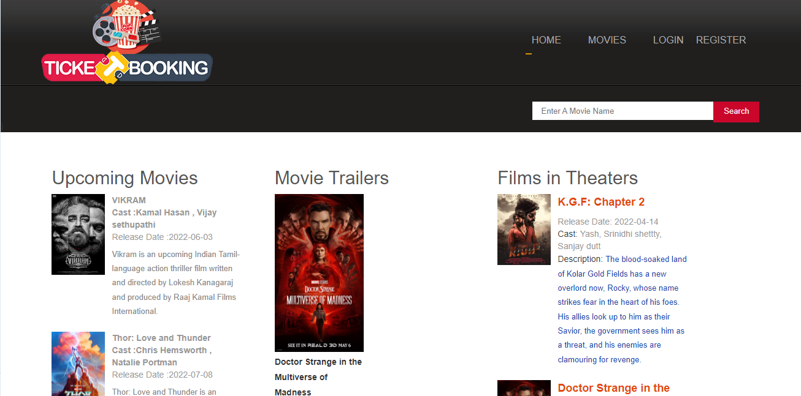

USER LOGIN PAGE

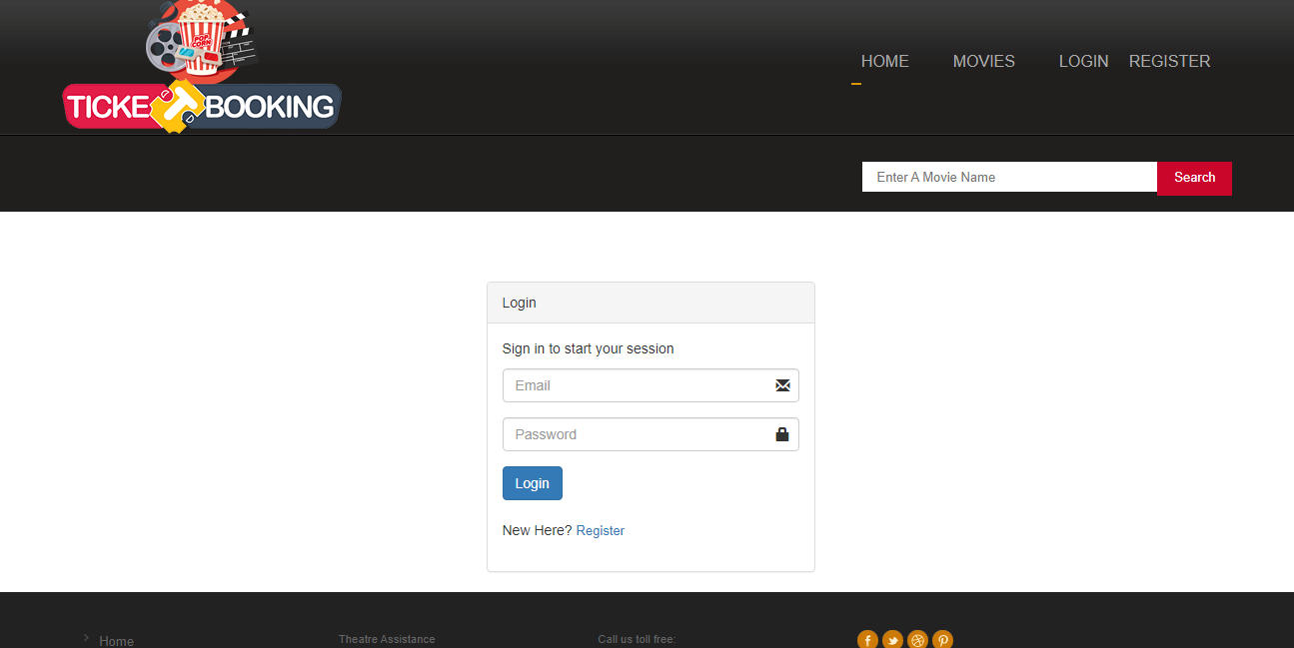
13
ADMIN LOGIN PAGE

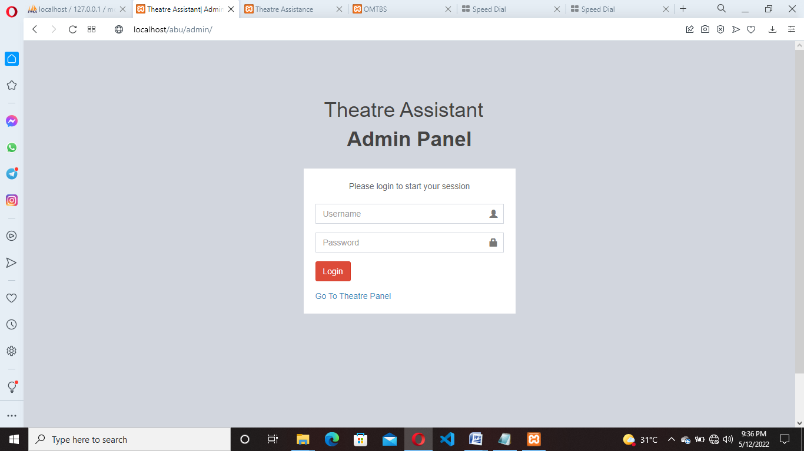

ADMN DASHBOARD PAGE

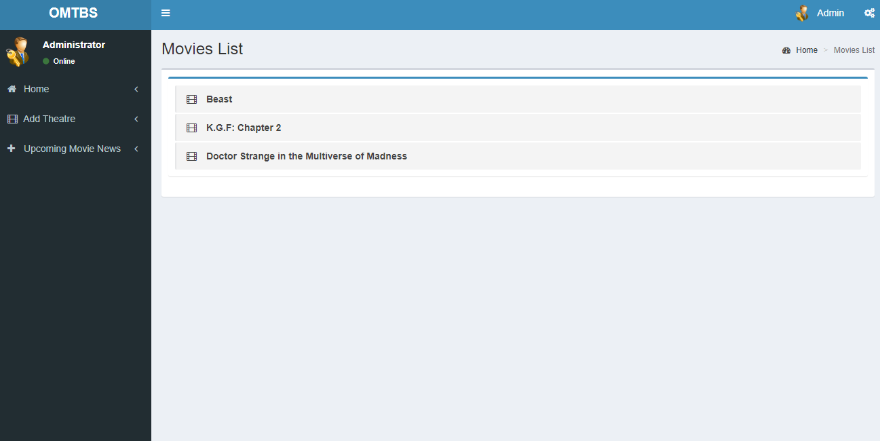

14
THEATRE PANEL LOGIN PAGE

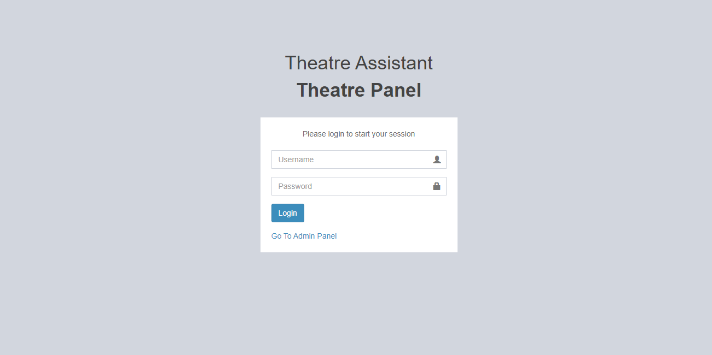

THEATRE PANEL DASHBOARD PAGE
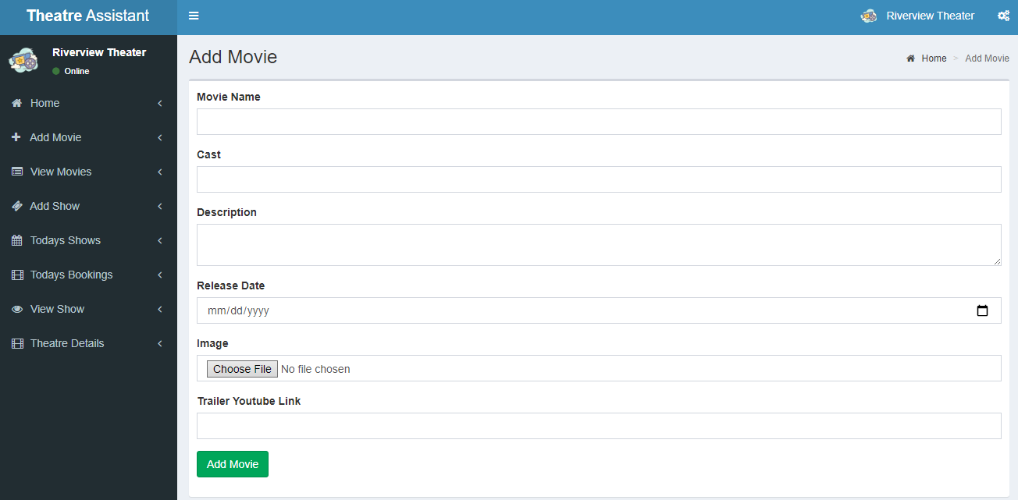

15

CHAPTER-8
CONCLUSION

8. CONCLUSION
Any project whether successful or not can yield valuable lessons. In fact, sometimes one can learn more from failure than success. Cinema Ticket Booking project brought useful lessons in communication, planning, management and overcoming the language barriers between technical and non-technical participants This project proved good for me as it provided knowledge of not only Programming in HTML, CSS and PHP, but also about all handling procedure related with “Cinema Ticket Booking”. It also Knowledge about the latest technology that will be great demand in future. This will provide better opportunities and guidance in future in developing projects independently. In conclusion, the list of recommendation resulting from this experience should be helpful to project participants dealing with similar issues and challenges when trying to improve business processes by utilizing information technology techniques.

16

CHAPTER-9
REFERENCES

9. REFERENCES
WEBSITES:
1)www.w3schools.com
2)www.javatpoint.com
3)www.tutorialspoint.com
4)www.stackoverflow.com
BLOG POSTS:
1)https://blog.getbootstrap.com/

17

